MCIS working on Internet Explorer 11
- open internet explorer click on “ALT” tab on your key board
- select “Compatibility View Settings” from “Tools” drop down box
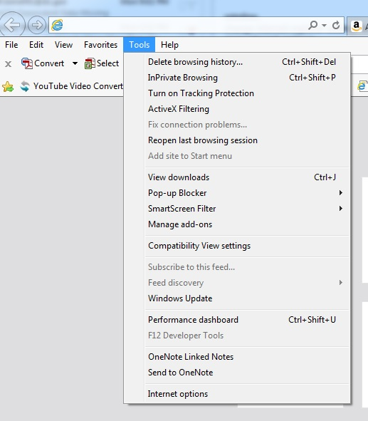
- In the add settings field type the following and click on the Add button after each
  - All DDS staff should add “dc.gov”
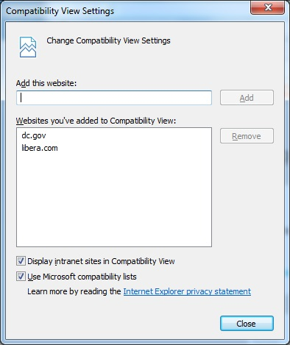
- Then click on the close button
- Close browser and access your respective applications from your desktop.

